

Functional Requirements Document (FRD)
  - J879904 Nauto Inc

Copyright© 2018, Oracle and/or its affiliates. All rights reserved.
Any reproduction or distribution of any part of this document without the prior written permission of Oracle + NetSuite is strictly prohibited.
The information included in this document is confidential and proprietary information of Oracle + NetSuite.
Version: March 3, 2022

Oracle + NetSuite
2955 Campus Drive, Suite 100
San Mateo, CA. 99403-2511

Project Information
Implementation Name | #SC-CUSTOMIZATION
Customer Name (Number) | 4525335 Nauto Inc
Job Name (Number) | J879904
Document Owner | Santiago Estellano
Project Manager | Santiago Estellano
Lead Developer | Ilan Daniele

Document Version History
Rev | Date | Author(s) | Change Summary
1.1 | 24Oct2022 | SE; ID | Initial Draft

Table of Contents
1 Business needs 4
2 Impacted areas/modules [Optional as output] 4
3 Acceptance criteria 4
4 Solution proposal 4
5 Prerequisites 5
6 Assumptions 5
7 Constraints and limitations 5
8 Risks 5

Business needs
GUIDELINE FOR THIS SECTION (DELETE TEXT BELOW ONCE THIS SECTION IS COMPLETED)

User Story: “As Nauto Inc. administrator, I want customers to see a clear reference to their legal entity name and FDA date before placing an order, so that there is less confusion regarding pricing for our products”

Impacted areas/modules

The customer’s legal name and FDA date will be displayed in the checkout review page, before the Delivery Method section

Acceptance criteria

When navigating to the checkout, client is able to see its legal name and the FDA date before placing an order.

Solution proposal

A new extension will be created; this extension will add 2 custom fields to the checkout review page on NetSuite’s checkout process.
These two custom fields will be showed above “Delivery Methods” section, one called “Customer Legal Name” (field id: custentity2) and the following “FDA Date” (field id: custentity3). Both will display content from NetSuite’s backend. This information would be fetched from the customer record.

You can see in the following screenshot where these 2 fields will be located:
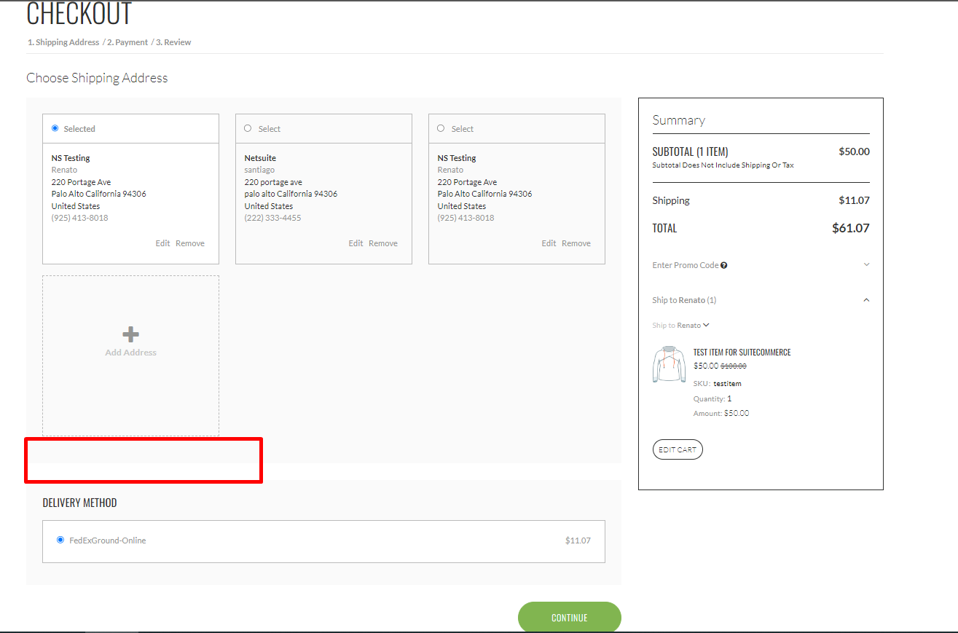

Prerequisites

Prerequisites include:
- Scriptable Cart must be enabled. (Review this, we are not using it)
- Content of custom fields will be provided by Nauto Inc. in the corresponding customer record

Assumptions

Constraints and limitations

Content of fields exposed at checkout depends on customer record data available

Risks

Oracle + NetSuite Professional Services and Customer are in agreement that the information documented above is accurate and representative of the customer’s business needs. This document will act as the basis for all subsequent implementation activities.
Document delivery date: Oct 24th 2022

